**BEHAVIOUR POLICY**

**FEBRUARY 2017**

**AUTHOR: K TAGUE**

**WMG ACADEMY FOR YOUNG ENGINEERS**

# BEHAVIOUR POLICY

|  |  |  |  |
| --- | --- | --- | --- |
| **Author:** | K Tague | **Version:** | 3.0 |
| **Date Approved:** | February 2017 | **Date for Review:** | August 2018 |
| **Monitoring, Review and Evaluation:** KT and Board of Governors | | | |

1. **Introduction**

The WMG Academy for Young Engineers provides for young people, real opportunities for learning in a caring, supportive and, above all, business-like environment. Standards and expectations are high emulating employer expectations, routines and practice. All learners are provided with opportunities to take responsibility through ownership of their actions and performance whilst respecting others and valuing diversity. The behaviour policy is a statement of good practice that covers all aspects of the WMG Academy and contributes to the development of a positive, inclusive ethos and the maintenance of appropriate behaviour conducive to outstanding learning.

All members of the academy are expected to help ensure the existence of a business-like atmosphere, where courtesy, working with others and mutual respect are basic routines. The WMG Academy Code of Conduct and the Academy/Home Contract make explicit expectations and can be found in the Appendices.

**2.0 Aims and Objectives**

The WMG Academy behaviour policy aims to:

* secure a climate for effective teaching, learning, achievement and learner safety;
* ensure a rigorous and consistent approach to the positive management of behaviour;
* place an emphasis on modelling and rewarding positive behaviour and creating reflective learners who show empathy and understanding towards others;
* promote behaviour that will maintain a ‘business like, business led’ ethos in and around the academy;
* provide a framework for managing and improving the behaviour of learners who behave negatively towards themselves, other learners and adults.

**3.0 Principles**

To ensure the achievement of the aims of the policy:

* The policy will be consistently applied where WMGA students are on the Westwood Academy site during the Academy day or during enrichment activities
* all members of staff will be made aware of the principles and protocols of the behaviour policy initially, through their induction;
* all members of the academy community are entitled to learn in a secure and safe environment;
* all academy staff and learners should show respect for one another;
* good behaviour should be rewarded and consequences should always be applied consistently for unacceptable behaviour;
* appropriate action should be taken to reduce the risk of poor behaviour occurring, including particular attention to preventing behaviour issues arising amongst/or to vulnerable groups;
* all members of the academy community should be listened to;
* learners should act as appropriate ambassadors for the academy on, for example, academy visits, work placements, sports events, journeys to and from the academy and during visits from business partners;
* all staff should model positive behaviour and promote it through active development of learners’ social, emotional and behavioural skills;
* all members of the academy should understand and accept the principles on which the behaviour policy is grounded.
* the academy will have a member of staff who is trained in Restraint Techniques

Behaviour which fails to follow the principles listed above will be liable to sanction. A specific list of expectations of behaviour regarding these principles is included in Appendix 3. (Incidents of inappropriate behaviour should be reported directly to a member of the SLT)

**4.0 Definitions**

The WMG Academy defines acceptable behaviour as that which promotes courtesy, team work, developing others, co-operation and consideration from all learners in terms of their relationships with others within/outside the academy, with academy staff, business partners or with other persons within/outside the academy premises.

At the academy examples of unacceptable behaviour include non-compliance, low-level disruptive or ‘off-task’ behaviour, name-calling, verbal abuse, threatening language or behaviour, intimidation, physical abuse, bullying, cyber-bullying and harassment, including racist, sexist and homophobic abuse, deliberate damage and theft of academy property.

1. **Roles and Responsibilities**

**5.1 Key staff and their roles**

* **Teacher -** Manages the behaviour during the lesson to ensure positive outcomes for young people and plans. If appropriate, intervention strategies for individual students and groups are discussed with the Learning Support Assistant.
* **Tutor -** Counsels learners through their programme of study and Individual Learning Plan (ILP), discussing with them areas where they are failing to perform or live up to the academy’s standards and expectations. Mentors will also discuss with parents/carers any issues which are impairing the learning of learners or their impact upon the learning of others. If a referral to the Student Intervention Group is required, then the mentor should be part of the discussion process with the Student Intervention Group on the most appropriate support stage and strategy.
* **Student Intervention Group (SIG) -** The Student Intervention Group through the Extended Leadership Team [ESLT] is headed by the Associate Principal and uses MIS data and feedback from Subject Leads from across the academy to have data-led conversations that determine intervention stages and appropriate learner support. (See Appendix 3)
* **Senior Leadership Team** - Respond to serious issues that require sanctions which are only within the authority of the Senior Leadership Team. They also provide support to those they line manage within the process to ensure they can deliver on the goals and aspirations of the academy to ensure outstanding behaviour for learning conducive to a business-like environment at all times.
* **Associate Principal** **via Assistant Principal -** Has oversight of the system and receives regular reports on the rewards and sanctions to ensure that policy is being followed within the academy. In addition, receives a regular report on all learners who have been referred to the Student Intervention Group and an update on progress with these learners and other vulnerable groups. The Associate Principal will ensure that the Governing body receives regular reports on the behaviour of learners at the academy over the course of their meeting cycle.
* **Governors -** The Governors of the WMG Academy will ensure that the academy has an up to date and relevant behaviour policy that is available to parents/carers. Governors will also ensure that policies and procedures are reviewed regularly.

**6.0 Taking account of Race, Religion and Culture**

We are committed to promoting equality and diversity for all by regularly monitoring our policies and practices. It is the responsibility of all Teachers and staff to ensure that they are well informed about cultural differences and that these are taken into account when applying academy rules. It is also the expectation that the Teachers will make business partners involved in the delivery of learning sessions aware of this. Teachers and staff should ensure that they are fully aware of equal opportunities legislation as it relates to behaviour policies. It is the responsibility of the Teacher, staff and business partners to challenge any form of discrimination as would be common practice in the business and work environment.

All racist incidents are to be reported to the Assistant Principal or pastoral team for further investigation and if appropriate, included on the central log and a restorative behaviour intervention should be put into place. (Further details in the Anti Bullying Policy and Equality Policy.)

1. **Rewards and Sanctions**

**7.1 Teaching and Learning Ethos**

Staff at the WMG Academy are expected to take positive approaches to learning which emphasise personal development and focus on individual learners and their ability to develop the kinds of behaviour skills and competencies that will allow them to respond effectively to a dynamic employment market. Within the academy, the fulcrum for all teaching and learning centres on a commitment to develop in learners: respect, self-management, and reflectiveness.

Teachers will start and end every lesson with a routine that models appropriate behaviour, rewards achievement and encourages the removal of barriers to learning. They will, wherever possible, use the language of ‘choice’ to de-escalate and depersonalise potential conflicts, emphasising positive messages about learning, rather than having negative discussions about behaviour. (Further guidance on the practical implications of teaching in larger spaces can be found in the Teaching and Learning Policy.)

Teachers will select activities and arrange their learning space to provide an interesting, stimulating, engaging curriculum experience suited to a range of abilities, learning styles and pathways. A commitment to planning for individual groups of learners must be evident in every lesson**.** (Further guidance in the Teaching and Learning policy.)

**7.2 Celebrating Success and Rewards**

The WMG Academy MIS system is used as the vehicle to record learner points in two categories: achievement and behaviour.

Student points will allow access to a wide range of awards and the points totals will be updated on a regular basis and shared with students on a half termly basis.

Achievement points will be awarded for:

* **Expectations – Good**

To be issued when a student has worked particularly well and completed all tasks asked of them

* **Expectations – Excellent**

To be issued when a student has worked to a high standard and completed all tasks in a timely manner.

* **Expectations – Outstanding**

To be issued when a student has completed all tasks to a high standard, in a timely manner and helped others.

* **Key Skills – Leadership**

To be issued when a student has demonstrated good leadership skills during lesson.

* **Key skills – Contribution**

To be issued when a student has made a positive contribution to the lesson, this could be verbal or through demonstration.

* **Key Skills – Professionalism**

To be issued when a student has shown professional behaviour both inside and outside the classroom.

* **Key Skills – Resilience**

To be issued when a student has stuck to a task that may have been difficult to them, worked hard and completed said task.

* **Caught doing good**

Here at WMG we want to encourage students to make the right decisions for themselves. If you see a student in or around the academy doing something that you feel was a good decision, showed mature behaviour and was helpful to others please issue them with a caught doing good on Progresso. Said student will be issued with recognition and praise in the next assembly which will hopefully encourage them to continue on a positive path. Please do not let the student know that you are issuing them with the Caught doing Good, we want to encourage students to act positively because it is the right thing to do, not because someone is watching.

* **Student of the week**

Each week 1 student from each year group will be awarded with student of the week. This could be issued for a number of reasons and the head of year will decide each week who the nominated student is, the students picture will be displayed on our student of the week board and a display played on the big screen for all to see.

**7.3** Learner success should be celebrated regularly and consistently and will include:

* praise letters from both academy staff but also ‘headed paper’ letters from employers to recognize commission success;
* certificates of commendation;
* employer certificates;
* learner portfolio of skills, competencies and successes;
* photographs and acknowledgement on the *Rewards and Achievement* section of the academy website;
* acknowledgement and recognition in the learner achievement section of the academy newsletters and blogs;
* gift vouchers
* year group reward assemblies which will be held half termly.

In addition, at the end of each year, learner success and achievements will be recognized through an Employers Celebration evening where prizes will be awarded.

**7.4 Supporting Behaviour for Learning and Sanctions** (Further guidance in Appendix 4)

Learners can have points recorded on the MIS system for inappropriate or unacceptable behavior. Behaviour points will be shared on a regular basis with learners and their staff to enable reflection, support and appropriate intervention to take place.

Behaviour points can be recorded for:

* punctuality concerns;
* low-level disruption;
* inappropriate behaviour towards another learner;
* inappropriate behaviour towards an adult;
* critical Incidents;

**8.0 Dealing with Incidents of Inappropriate or Unacceptable Behaviour**

**8.1 Incidents during lessons**

Incidents occurring within a lesson should be escalated as follows (assuming incidents are not those requiring exclusion from the WMG Academy):

* The Teacher (the person responsible for the learning of a group of learners at a given moment in time) deals with the incident and uses rewards and sanctions as appropriate. The incident is logged with behaviour points on the MIS system by the Teacher.
* The teacher in the first instance, has the responsibility to issue sanctions, record points or make parents and senior staff aware if appropriate.
* Repeated incidents are referred to the Curriculum Leader (or picked up by the Student Intervention Group as a result of the individual behaviour points log) who has the responsibility for investigating, contacting home as appropriate and taking relevant action;
* The teacher escalates incidents to the Subject Lead/Subject Line Manager, if they require further investigation or to a member of the SLT, if they are critical incidents.

**8.2 Incidents Outside Of Lessons**

Incidents occurring outside a lesson should be managed and escalated as follows (assuming incidents are not those deemed critical that could lead requiring exclusion from the WMG Academy):

* Person observing the incident or made aware of the incident deals with it and uses the rewards and sanctions policy as appropriate. The incident is logged on the MIS system with behaviour points;
* Repeated incidents are referred to the learner's tutor (or picked up by the Learning Support Group as a result of the cumulative log of behaviour points) who has the responsibility for investigating, contacting home as appropriate and taking relevant action;
* The tutor escalates incidents to the Pastoral team if they require further investigation or are of a serious nature;
* The Pastoral team investigates, contacting home as appropriate and takes relevant action.

**9.0 Relevant Action**

Action comprises two elements, the first being a reward/sanction appropriate to the behaviour demonstrated by the learner. The second is a discussion on the behaviour which has led to the reward/sanction which will clearly be additional praise in the case of the reward or a discussion on why the sanction was necessary and the process by which the learner ensures that this type of behavior is not repeated.

Before sanctions are imposed for minor transgressions, the following should be followed by all staff:

* a warning issued to the learner which informs them that their behaviour is unacceptable; [B1]
* if the behaviour continues and is repeated the warning should be reissued;[B2]
* if the behaviour continues a sanction should be issued to the learner.[B3]

Any sanctions should be applied fairly and to individuals – **never to groups**. Whole group detentions or punishments are **not** acceptable at the academy and must not be used at any time.

**10.0 Sanctions (See Appendix 4)**

* Being moved to work away from the core learning group. This is supervised by the Teacher and used as an opportunity to discuss inappropriate behaviour. Behaviour points should be logged on the academy MIS;
* Remaining behind following a learning session to discuss behaviour: supervised by the Teacher and used as an opportunity to discuss inappropriate/unacceptable behaviour;
* Loss of break time: supervised by the individual member of staff concerned. Behaviour points should be logged on the academy MIS;
* Subject detention: these are held at lunchtime and supervised by Curriculum Leaders;
* B3 after school detentions held for 20 minutes and are supervised by a member of ESLT
* Students who get 2 or more late marks in a 1 week period will be given an after school detention for 1 hour on the following Monday.
* Failure to attend an after school detention will result in isolation the following day.
* Senior Leadership Team Detention: these are held after school and supervised by a member of senior leadership team. Learners are placed in these as a result of a Critical Incident or as a result of failure to attend one of the above detentions or a refusal to engage in the intervention support offered through the Pastoral team
* Principal’s Saturday detention: arranged by the Principal as required on a Saturday morning between 9:30 am and 11:30 am. Learners are placed in this detention for failure to attend Principal's lunchtime detention or by the Principal for serious transgression of the WMG Academy's Behaviour Policy;
* Internal exclusion: isolation with a senior member of staff or member of the Student Intervention Group and removal from contact with other learners;
* External exclusion: exclusion from the Academy for one of the reasons listed below.

(Appendix 3 provides a summary of the staged approach to learner support, intervention and sanctions.)

**10.1** Teachers have the right to teach, Students have the right to learn, any student who disrupts the learning of others will be removed from lesson after 3 warnings are given. See Appendix 4

**11.0 Exclusions** (See separate Exclusions policy)

The following are examples of incidents which could lead to exclusion and should be referred immediately to the Pastoral team in the first instance or another member senior member of staff:

* abuse towards a member of staff (physical or verbal);
* unprovoked assault on a fellow learner;
* possession of drugs;
* repeated defiance;
* vandalism;
* theft;
* incidents involving racial, xenophobic or racial abuse;
* incidents involving sexual harassment;
* bullying.
* Failure to uphold the standards and ethos of WMG Academy for Young Engineers whilst travelling to and from the academy, on work placements and during educational visits.

Fixed term and Permanent Exclusions from the WMG Academy can only be authorised by the Executive Principal or Associate Principal [in the absence of the Executive Principal]

1. **Malicious allegations against staff -** (Dealing with Allegations Of Abuse Against Teachers and Other

Staff, DfE 2012)

Where a learner makes an accusation against a member of staff and the accusation is shown to have been deliberately invented or malicious, the Executive Principal will consider whether to take disciplinary action in accordance with this policy.

Where such an allegation is made, appropriate support will be provided to the member(s) of staff affected.

1. **Use of Reasonable Force**

(Use of reasonable force: advice for Headteachers, staff and governing bodies, DfE July 2013)

Any use of force by staff will be reasonable, proportionate and absolutely necessary. Reasonable force will be used in accordance with the DfE guidance and only when immediately necessary and for the minimum time necessary to prevent a learner from doing or continuing to do any of the following:

* committing a criminal offence;
* injuring themselves or others;
* causing damage to property, including their own;
* engaging in any behaviour prejudicial to good order and discipline at the academy or among any of its learners, whether that behaviour occurs in a learning space or elsewhere.

Where restraint is used by staff, this is recorded in writing and the learner's parent/carers will be informed about serious incidents involving the use of force. Force is never used as a form of punishment. [See the Academy’s separate po9licy on Reasonable Force]. A log is kept and is reviewed by the Assistant Principal and the Executive Principal to ensure that reasonable force is being used appropriately.

1. **Searching Learners** (Searching, Screening and Confiscation, DfE Feb 2014)

Searches generally: If staff believe a learner is in possession of a prohibited item, it may be appropriate for a member of staff to carry out:

* a search of outer clothing and/or;
* a search of academy property, e.g. learners' lockers or;
* a search of personal property (e.g. bag or pencil case within a locker);
* searches will be conducted in such a manner as to minimise embarrassment or distress. Any search of a learner or their possessions will be carried out in the presence of the learner and another member of staff.
* Where a learner is searched, the searcher and the second member of staff present will be the same gender as the learner.

**Informed consent**: The Academy staff may search a learner with their consent for any item which is prohibited or banned by the academy rules. If a member of staff suspects that a learner has a prohibited or banned item in his / her possession, they can instruct the learner to turn out his or her pockets or bag.

If the learner refuses, sanctions will be applied in accordance with this policy.

**Searches without consent**: In relation to prohibited items, as defined below, the Associate Principal, and staff authorised by the Associate Principal, may search a learner or a learner's possessions, without their consent, where they have reasonable grounds for suspecting that a learner has a prohibited item in their possession.

**Prohibited items**: knives or weapons, alcohol, illegal drugs and stolen items and any other items as defined by the Associate Principal. Where the Associate Principal, or staff authorised by the Associate Principal, find anything which they have reasonable grounds for suspecting is a prohibited item, they may seize, retain and dispose of that item as appropriate in accordance with the DfE guidance on Screening, searching and confiscation.

1. **Monitoring, Review and Evaluation**

This policy will be reviewed annually and will take into account feedback from a range of stakeholders.

**Linked Policies**

Teaching and Learning

Exclusions

Educational Visits and Learning Outside The Classroom

Anti-Bullying

Safeguarding

**Appendix 1**

**The WMG Academy for Young Engineers Code of Conduct**

**In Learning Sessions**

* attend every session;
* arrive on time;
* bring the correct equipment to all learning sessions;
* begin and end the learning session in an orderly manner;
* work hard and always do your best;
* ask for help when required;
* consider the effect of your conduct on others;
* switch off your mobile devices when asked to do so;
* wear PPE as advised and follow all safety guidance.

**In Transition**

* walk around the building rather than running showing respect for the resources of the academy;
* be ready to help and support others;
* move safely around crowded areas of the building and between floors.

**In General**

* behave with honesty and integrity;
* speak politely to everyone;
* use language which is neither abusive or offensive;
* believe other learners can develop and encourage them to do so;
* listen to others and expect to be listened to;
* only eat in the designated areas and put litter in bins;
* respect other people’s property and equipment;
* report any damage that you see.

**Out of School**

* Uphold the standards and ethos of WMG Academy for Young Engineers on work placements, educational visits and travelling to and from the academy.

**Appendix 2:**

**WMG Academy Rules for Learners**

1. Be ready to learn: mobile phones switched off and in bags; ear phones out of sight; equipment and books on the table.
2. Listen silently when someone speaks. Be respectful and tolerant towards others.
3. Follow instructions straight away.
4. Participate in lessons and respect the Academy ethos of ‘business like, business led’. Be punctual, respectful, courteous, and use appropriate language.
5. Always try your best and encourage each other.

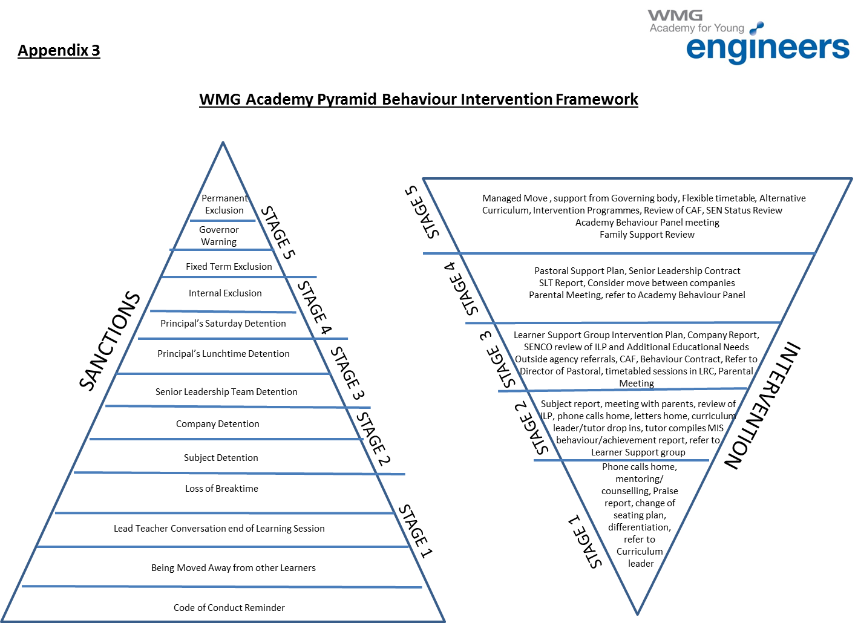

**Appendix 4: Issuing Sanctions**

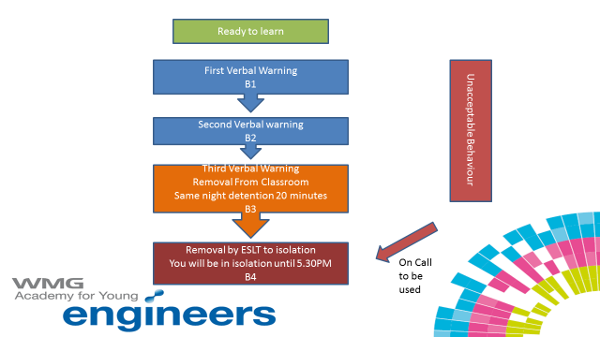

**Appendix 5**

**Home – WMG Academy Contract**

The aim of the agreement is to make clear to learners, parents/carers, staff and governors that they have an equally important part to play in helping each individual learner to make the best use of the opportunities available at the WMG Academy.

We believe that success is built upon an open and supportive partnership between our learners, parents, staff and governors. We aim to provide all our learners with stimulating, relevant and challenging learning experiences which will equip them with the employability skills and knowledge to face the challenges of the 21st century.

**Learners**

Each learner has a responsibility to:

* take ownership of their own actions and performance;
* respect other learners, staff, visitors and themselves and be aware that racism, intolerance and bullying are unacceptable ;
* wear the required business dress;
* complete all work on time to the best of their ability;
* respect Health and Safety regulations;
* attend regularly and punctually and be adequately prepared for the day;
* behave in a business like manner at all times and adhere to the Code of Conduct.

Learners can expect from the WMG Academy:

* to be set challenging work which is assessed regularly;
* to have frequent feedback on progress;
* to be rewarded for positive contributions to the academy;
* to have behaviour monitored and appropriate disciplinary action taken when it falls short of the required standard;
* to have their parents/carers regularly informed of progress;
* to have a safe and caring environment to work in;
* to have advice, care and support when needed from all staff.

**Parents and Carers**

Each parent and carer has an important responsibility to work closely with their children and the staff to support achievement at the WMG Academy. We ask you, as parents and carers:

* to ensure your child attends regularly and punctually as required by law;
* to keep the academy informed of anything which you believe might affect your child's progress at the academy especially absence, illness, change of family situation;
* not to take holidays in term time;
* to take an interest in your child's work when they are at home;
* to attend review and progress days to meet your child personal tutor;
* to support the business dress code ;
* to support the implementation of the academy’s code of conduct;
* to send your child to the academy, prepared for the day ahead.
* **The WMG Academy will ensure**
* that parents are informed regularly of academic progress;
* that parents are informed of any aspects of behaviour that required action by staff;

**Governors**

Our Governors will carry out their legal responsibilities to the WMG academy and ensure

* that academy policies provide care for every learner;
* that funding received by the academy will be used responsibly to provide the curriculum and support services ;
* that they will meet regularly to carry out their function and liaise with academy business partners ;
* that they will visit the academy regularly and update business partners on progress and further opportunities.

Signed: _________________________________(Learner) Date: _____________

Signed: _________________________________(Parent/Carer)) Date: _____________

Signed: ________________________________(Associate Principal ) Date: _____________

**Appendix 6**

**Specific Behaviour Expectations**

**Use of mobile devices (BVOD – Bring Your Own Device)**

The WMG academy embraces the use of new technology by learners particularly in terms of allowing them to bring with personal devices to enhance and develop their learning sessions. However, these devices are subject to an acceptable usage agreement and safeguarding protocol and are used under the explicit direction of the Teacher.

Any learner using a mobile device when specifically directed not to (use includes receiving messages, calls and listening to music) will have the device confiscated for the day. It is made clear in the Academy rules that mobile phones should be switched off and in the student’s school bag. The device may be collected from learner reception after detention, at the end of the same day. Detention finishes at 3.35PM on Monday and 4.40PM Tuesday to Friday. Parents and carers may have to arrange for alternative travel arrangements home from the Academy if a student intends to collect the confiscated item at the end of the Academy day, after detention. Parents and Carers are informed if a mobile phone has been confiscated by a member of staff before the end of the Academy day.

**Use of MP3 players and iPod’s**

The use of MP3 players and iPod’s is permitted within the academy at social times outside of lessons and directed learning sessions. MP3 players and iPod’s brought to the academy must be switched off and kept out of site in bags or in lockers at all times that learners are on site.

Any learner using an MP3 player or iPod (or similar) where it is not permittedwill have the equipment confiscated for the day. Inappropriate use and/or failure to adhere to the academy rules will result in the confiscation of the electronic device. The collection of the confiscated item will take place at the end of the school day after detention. The WMGA E-Safety Policy has explicit guidelines on the use of capturing digital images on mobile devices.

**Chewing gum**

Learners are not permitted to chew gum anywhere on the Academy grounds. The disciplinary process outlined in The WMG Academy Behaviour Policy will be applied to any learner breaching this rule.

**Coats, scarves and hats**

Learners are not permitted to wear coats, scarves, hatsor other outer garments on top of/under business dress such as hoodies or sweatshirts in the academy building. Coats, scarves and hats must be removed on entry. Learners found to be wearing any of these itemswill have them confiscated until the end of the academy day when they may be collected from reception. Continuous breach of this rule will result in the disciplinary process outlined in WMG Behaviour Policy being applied.

**Eating**

Learners are only permitted to eat in designated eating areas such as the coffee pods or shared canteen on the Westwood Academy site. Learners are not permitted to eat in any other area in the academy. Learners will be expected to dispose of litter in the bins provided. Breach of this rule will result in the disciplinary process outlined in WMG Behaviour Policy being applied.

**Movement around the building**

Learners are expected to move around the building quietly on the left hand side. Running in the building is not permitted. Due to the flexible nature of learning sessions for specific groups, the academy may operate staggered break andlunch times for groups and hence, learners are expected to talk quietly in the break-out areas and corridors. Breach of this rule that disturbs the learning of others’, will result in the disciplinary process outlined in WMG Behaviour Policy being applied.

**Headsets in laptops**

Learners are only permitted to use headsets in laptops/mobile devices to access learning resources as part of the curriculum. Learners are not allowed to use headsets to listen to music. Breach of this rule will result in the disciplinary process outlined in WMG Behaviour Policy being applied.

**Bullying**

Any allegations of bullying behaviour will be taken seriously at the Academy and any learner found to be displaying bullying behaviour will be dealt with in accordance with The WMG Academy Anti-Bullying Policy.

**Smoking**

The WMG Academy is a no smoking site. Learners are not allowed to smoke anywhere on academy premises, at any time on an educational visit (whether or not they are in uniform) or in any other location or during journeys to and from the academy. Any learner found in possession of cigarettes will have them confiscated indefinitely. Breach of this rule will result in the disciplinary process outlined in WMG Behaviour Policy being applied.

**General conduct**

Learners at the Academy are expected to behave with respect towards each other and towards Academy’s staff. All learners are expected to behave as if they were in the workplace and, as such, any behaviour that would not be acceptable in a place of work (such as swearing and public displays of affection) will not be tolerated. Breach of this rule will result in the disciplinary process outlined in WMG Behaviour Policy being applied.